Chapter 17, Solution 4.

f(t) = 10 – 5t, 0 < t < 2, T = 2, ω_{o} = 2π/T = π

a_{o} = (1/T) 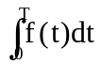 = (1/2)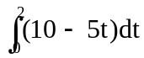 = 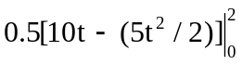 = 5

a_{n} = (2/T) 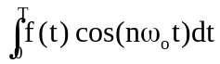 = (2/2) 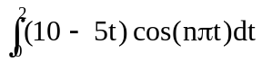

= 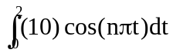– 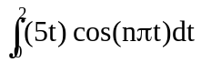

= 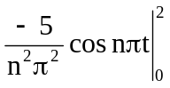 + 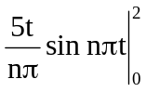 = [–5/(n²π²)](cos 2nπ – 1) = 0

b_{n} = (2/2) 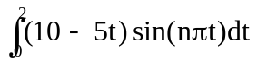

= 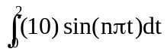– 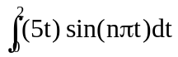

= 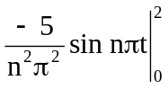 + 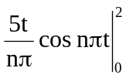 = 0 + [10/(nπ)](cos 2nπ) = 10/(nπ)

Hence

f(t) = 

